Webmail Client

📧 What is Webmail?
# Source: AI Source: Provided by: [Data Path: Persons Table -> ID Column: 1, Name_En Column: Motasem Essam] -> From: [ChatGPT] on [1/21/2026]
Webmail is an email client that runs in your web browser, allowing you to send, receive, and manage emails without needing to install any software.

🌐 Key Features of Webmail
# Source: AI Source: Provided by: [Data Path: Persons Table -> ID Column: 1, Name_En Column: Motasem Essam] -> From: [ChatGPT] on [1/21/2026]
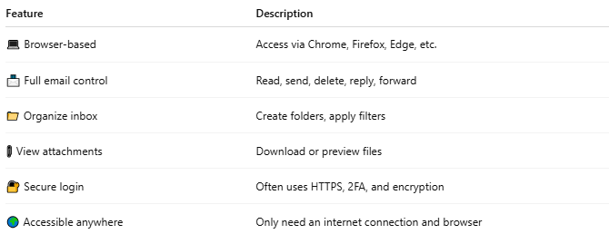

Feature | Description
💻 Browser-based | Access via Chrome, Firefox, Edge, etc.
📨 Full email control | Read, send, delete, reply, forward
📁 Organize inbox | Create folders, apply filters
📎 View attachments | Download or preview files
🔐 Secure login | Often uses HTTPS, 2FA, and encryption
🌍 Accessible anywhere | Only need an internet connection and browser

🧰 Examples of Webmail Services
# Source: AI Source: Provided by: [Data Path: Persons Table -> ID Column: 1, Name_En Column: Motasem Essam] -> From: [ChatGPT] on [1/21/2026]
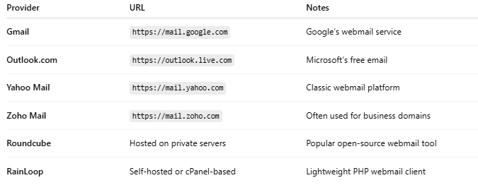

Provider | URL | Notes
Gmail | https://mail.google.com | Google’s webmail service
Outlook.com | https://outlook.live.com | Microsoft’s free email
Yahoo Mail | https://mail.yahoo.com | Classic webmail platform
Zoho Mail | https://mail.zoho.com | Often used for business domains
Roundcube | Hosted on private servers | Popular open-source webmail tool
RainLoop | Self-hosted or cPanel-based | Lightweight PHP webmail client

🔁 How Webmail Works
# Source: AI Source: Provided by: [Data Path: Persons Table -> ID Column: 1, Name_En Column: Motasem Essam] -> From: [ChatGPT] on [1/21/2026]
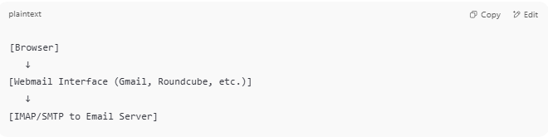

[Browser]
↓
[Webmail Interface (Gmail, Roundcube, etc.)]
↓
[IMAP/SMTP to Email Server]

- Webmail is just a front-end.
- It connects in the background to IMAP (for reading emails) and SMTP (for sending).

🧠 Webmail vs. Desktop/Mobile Email Clients
# Source: AI Source: Provided by: [Data Path: Persons Table -> ID Column: 1, Name_En Column: Motasem Essam] -> From: [ChatGPT] on [1/21/2026]
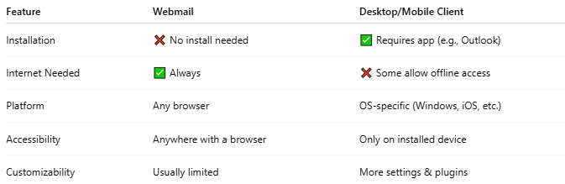

Feature | Webmail | Desktop/Mobile Client
Installation | ❌ No install needed | ✅ Requires app (e.g., Outlook)
Internet Needed | ✅ Always | ❌ Some allow offline access
Platform | Any browser | OS-specific (Windows, iOS, etc.)
Accessibility | Anywhere with a browser | Only on installed device
Customizability | Usually limited | More settings & plugins

✅ Summary
# Source: AI Source: Provided by: [Data Path: Persons Table -> ID Column: 1, Name_En Column: Motasem Essam] -> From: [ChatGPT] on [1/21/2026]
Webmail is a browser-based email client that allows users to access their email from anywhere using just a web browser. It’s fast, convenient, and doesn't require installation.

